EASWARI ENGINEERING COLLEGE

# Maximizing Efficiency: Unleashing the Power of Parallel and Serial Interfaces



Introduction

Welcome to *Maximizing Eﬃciency: Unleashing the Power of Parallel and Serial Interfaces*. This presentation will explore

the beneﬁts of and serial interfaces



parallel

in optimizing system performance and data transfer.

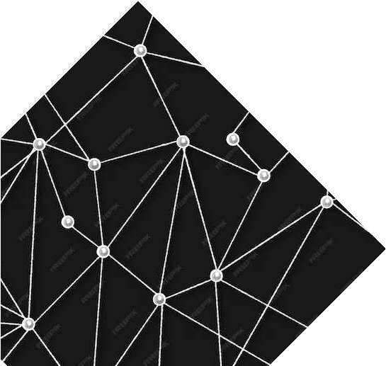

### Understanding Parallel Interfaces

Parallel interfaces allow for simultaneous transmission of multiple data bits, leading to faster transfer rates. However, they require more complex hardware and are susceptible to signal interference.



Leveraging Serial Interfaces

Serial interfaces transmit data sequentially, reducing the complexity of hardware and

minimizing interference. They are



signal

ideal for long-distance communication and oﬀer scalability.

### Comparing Performance



When it comes to performance, parallel interfaces excel in terms of speed and are highly suitable for short-distance communication. These interfaces allow multiple bits of data to be transmitted simultaneously, resulting in faster data transfer rates. On the other hand, serial interfaces oﬀer exceptional eﬃciency and are ideal for long-distance transmission. With serial interfaces, data is transmitted sequentially, one bit at a time, which ensures reliable transmission over longer distances. This makes serial interfaces a preferred choice in scenarios where data needs to be transmitted over extended distances without compromising on the integrity of the data.



### Implementing Parallel-Serial

Hybrid

A hybrid approach combines the speed of parallel interfaces with the eﬃciency of serial interfaces, oﬀering a balanced solution for diverse data

transfer requirements.



Optimizing Data Transfer

To maximize eﬃciency, it's essential to analyze the speciﬁc

of data transfer and select the most suitable interface. Tailoring the approach can lead to signiﬁcant



requirements

performance gains.



Enhancing System Performance



performance

By understanding the strengths and weaknesses of parallel and serial interfaces, organizations can enhance

their system and

achieve seamless data transfer across various applications and

environments.

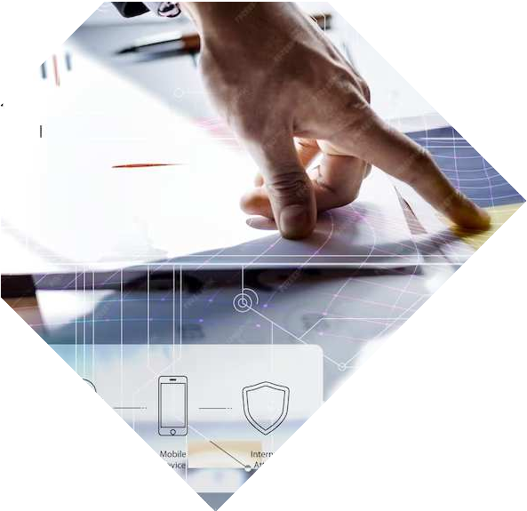

### Overcoming Interface Challenges

Challenges such as crosstalk, latency, and compatibility issues can impact interface performance. Addressing these challenges is crucial for unlocking the full potential of parallel and serial interfaces.



## Future Trends and Innovations

The future of interface technology holds promise for advancements in speed, reliability, and integration. Keeping abreast of these trends is essential for staying competitive in the digital landscape.



# Key Takeaways

In conclusion, the strategic use of parallel and serial interfaces can signiﬁcantly enhance system performance and data transfer eﬃciency. Understanding the nuances of each interface is crucial for making informed implementation

decisions.

Q&A and Conclusion

Thank you for your attention. Now, let's open the ﬂoor for any questions or discussions. In conclusion, harnessing the power of parallel and serial interfaces is a strategic imperative for maximizing eﬃciency in the digital age.

Thanks!



Do you have any questions?

#### [youremail@email.com](mailto:youremail@email.com)

+91 620 421 838

#### [www.yourwebsite.com](http://www.yourwebsite.com/) @yourusername